Informatics practices

Investigatory

Project



Topic : library management

Submitted by:

Ummer-ul-farooq c.a

NAJATH public school

South KALAMASSERY , kochi-682033

EMAIL :najath.pub.school@gmail.com



Department of computer SCIENCE

Certificate

This is to certify that master / kumari ________________Of class XII, roll no ________ has completed his /her Investigatory project in INFORMATICS PRACTICES during the year 2019-2020 on the topic ___________________.

INTERNAL PRINCIPAL EXTERNAL

EXAMINER EXAMINER

NAJATH public school

South KALAMASSERY , kochi-682033

EMAIL :najath.pub.school@gmail.com



BONAFIDE CERTIFICATE

This is to certify that master _____________________ of Najath Public

School, studying in class XII has completed his/her project

_________________________ under my guidance during the year 2019-20.

PROJECT GUIDE

**INDEX**

**ACKNOWLEDGEMENT**

1. **ABSTRACT**
2. **INTRODUCTION**
3. **FUNCTIONAL REQUIREMENTS**
4. **TABLES**
5. **SOURCE CODE**
6. **SCREENSHOTS**
7. **CONCLUSION**
8. **BIBLIOGRAPHY**

**ACKNOWLEDGEMENT**

This project bears an imprint of many people and I am extremely fortunate for having their support throughout the completion of my project work . I take this to covey my sincere gratitude to our beloved Principal **Dr. V.** **Manoranjini** and every other individual who has supported me in every way during the course of the project.

From the core of my heart, I express my heartfelt gratitude to our Informatics Practices teachers , Mrs. Sajmi Salam , for her supervisory guidance . I am always indebted for her kind support , constant encouragement and for leading us in a right path.

I wish to avail myself this opportunity to express a sense of gratitude and love to my beloved parents and my group members for their support, strength, help, and everything else . I thank all the people who encouraged and motivated me in day to day life.

At last but all, I think the almighty who showers blessings upon us.

**ABSTRACt**

The objective of the software project is to develop a computerized MIS to automate the functions of a Public Library This software project is also aimed to enhance the current record keeping system, which will help managers to retrieve the up-to-date information at right time in right shape.

The proposed software system is expected to do the following functionality-

* To provide a user friendly, Graphical User Interface (GUI) based integrated and centralized environment for MIS activities.
* The proposed system should maintain all the records and transactions, and should generate the required reports and information when required.
* To provide graphical and user-friendly interface to interact with a centralized database based on client-server architecture.
* To identify the critical operation procedure and possibilities of simplification using modern IT tools and practices.

In its current scope, the software enables user to retrieve and update the information from centralized database designed with My SQL . This software does not require much training time of the users due to limited functionality and simplicity. During the development of Public Library Information System project, Java Net Beans IDE, a powerful, open source event-driven form-based development environment is used for modular design and future expandability of the system .Despite of the best effort of the developer, the following limitations and functional boundaries are visible, which limits the scope of this application software .This software can store records and produce reports in pre-designed format in soft copy. There is no facility yet to produce customized reports. Only specified reports are covered .

**INTRODUCTION**

This software project is developed to automate the functionalities of a Public Library .The purpose of the software project is to develop the Management Information System (MIS) to automate the record keeping of Publishers, Books, Members and Book issue and receive transactions with a view to enhance the decision making of the functionaries. A MIS mainly consists of a computerized database, a collection of inter-related tables for a particular subject or purpose, capable to produce different reports relevant to the user. An application program is tied with the database for easy access and interface to the database. Using Application program or front-end, we can store, retrieve and manage all information in proper way.

This software, being simple in design and working, does not require much of training to users, and can be used as a powerful tool for automating a Public Library System . During coding and design of the software Project, Java NetBeans IDE, a powerful front-end tool is used for getting Graphical User Interface (GUI) based integrated platform and coding simplicity. As a back-end a powerful, open source RDBMS, My SQL is used as per requirement of the CBSE curriculum of Informatics Practices Course.

**FUNCTIONAL REQUIREMENTS**

As mentioned in the requirements, the Library Management System Software involves the following function or modules. It mainly consists of mainly 9 modules.

1. LOGIN

In this module, the user should enter the username and password to log in. after this it directs to the homepage in which we want to perform by clicking t he desired button.

1. MEMBER DETAILS MANAGEMENT

In this module, we can insert the details of the members of Library. Update the details of members, delete the details of members, search for a particular member through member id.

1. PUBLISHER DETAILS MANAGEMENT

In this module, we can insert the details of the publisher of Library. Update the details of publishers, delete the details of publishers, search for a particular publisher through publisher id.

1. BOOK DETAILS MANAGEMENT

In this module , we can insert the details about the book . such as the price of the book , author , accession no , date of publishing etc .

1. BOOK ISSUE

In this module , we can insert the details of the book issued by the library .

1. BOOK RETURN

In this module , we can keep the record of the members those who were returned the books issued by the library .

1. VIEWING MEMBER LIST

In this module , we can view the details of member of the library in a table .

1. VIEWING BOOK ISSUE

In this module , we can vie the details of book issue in a table .

1. VIEWING BOOK RETURN

In this module , we can view the details of book return in a table .

TABLES

MEMBERSHIP

|  |  |  |
| --- | --- | --- |
| FIELD | TYPE | DESCRIPTION |
| mid | varchar(30) | Members id |
| name | varchar(40) | Name |
| address | varchar(30) | address |
| Mobile | varchar(50) | mobile |
| Membersfee | varchar(40) | Members fee |
| Membersdate | varchar(50) | membersdate |
| status | varchar(60) | status |

PUBLISHER

|  |  |  |
| --- | --- | --- |
| FIED | TYPE | DESCRIPTION |
| pid | varchar(20) | Publisher id |
| Name | varchar(40) | Name of |
| adress | varchar(40) | Address |
| email | varchar(60) | Email |
| mobile | varchar(50) | mobile |

|  |  |  |
| --- | --- | --- |
| FELD | TYPE | DESCRIPTION |
| memberid | varchar(40) | Member id |
| membername | varchar(50) | Member name |
| membershipdate | varchar(50) | Membership date |
| mstatus | varchar(60) | Member status |
| accno | varchar(60) | Account number |
| boktittle | varchar(70) | Booktittle |
| Authors | varchar(40) | Authors |
| Pubname | varchar(60) | Publisher name |
| issuedate | varchar(50) | Issue date |
| status | varchar(40) | status |

BOOKISSUE

BOOKRETURN

|  |  |  |
| --- | --- | --- |
| FIELD | TYPE | DESCRIPTON |
| Mno | varchar(40) | Member number |
| Name | varchar(50) | name |
| Mdate | varchar(30) | Member date |
| Status | varchar(20) | Status |
| Accno | varchar(40) | Account number |
| Author | varchar(60) | Author |
| Returndate | varchar(70) | Return date |
| Returnstatus | varchar(60) | Return status |

SOURCE CODE

**//LOG IN//**

private void jButton1ActionPerformed(java.awt.event.ActionEvent evt) {

String a=t1.getText();

String b=new String(p1.getPassword());

if(a.equals("library")&&b.equals("1234"))

{

JOptionPane.showMessageDialog(null,"succesfully loged in");

}

else

{

JOptionPane.showMessageDialog(null,"incorrect user name and password");

}

HOMEPAGE h= new HOMEPAGE();

this.setVisible(false);

h.setVisible(true);

}

private void jButton2ActionPerformed(java.awt.event.ActionEvent evt) {

t1.setText(" ");

p1.setText(" ");

}

private void jButton3ActionPerformed(java.awt.event.ActionEvent evt) {

System.exit(0);

}

**//MEMBER DETAILS MANGEMENT//**

private void jButton1ActionPerformed(java.awt.event.ActionEvent evt) {

String a=t1.getText();

try {

Class.forName("com.mysql.jdbc.Driver");

Connection con = (Connection)DriverManager.getConnection("jdbc:mysql://localhost:3306/Library","root","user");

Statement stmt = (Statement) con.createStatement();

String query = "SELECT * FROM MEMBERSHIP WHERE MID='"+a+"';";

ResultSet rs=stmt.executeQuery(query);

while(rs.next())

{

String b=rs.getString("name");

String c=rs.getString("address");

String d=rs.getString("mobile");

String e=rs.getString("membersfee");

String f=rs.getString("membersdate");

String g=rs.getString("status");

t2.setText(b);

t3.setText(c);

t4.setText(d);

t5.setText(e);

t6.setText(f);

t7.setText(g);

}}

catch (Exception z) {

JOptionPane.showMessageDialog(this,z.getMessage());

}

// TODO add your handling code here:

}

private void jButton2ActionPerformed(java.awt.event.ActionEvent evt) {

String a=t1.getText();

String b=t2.getText();

String c=t3.getText();

String d=t4.getText();

String e=t5.getText();

String f=t6.getText();

String g=t7.getText();

try {

Class.forName("com.mysql.jdbc.Driver");

Connection con = (Connection)DriverManager.getConnection("jdbc:mysql://localhost:3306/Library","root","user");

Statement stmt = (Statement) con.createStatement();

String query = "insert into membership values('"+a+"','"+b+"','"+c+"','"+d+"','"+e+"','"+f+"','"+g+"')";

stmt.executeUpdate(query);

}

catch (Exception z) {

JOptionPane.showMessageDialog(this,z.getMessage }

private void t6ActionPerformed(java.awt.event.ActionEvent evt) {

}

private void t4ActionPerformed(java.awt.event.ActionEvent evt) {

}

private void jButton6ActionPerformed(java.awt.event.ActionEvent evt) {

String a=t1.getText();

try {

Class.forName("com.mysql.jdbc.Driver");

Connection con = (Connection)DriverManager.getConnection("jdbc:mysql://localhost:3306/Library","root","user");

Statement stmt = (Statement) con.createStatement();

String query = "DELETE FROM MEMBERSHIP where mid='"+a+"';";

stmt.executeUpdate(query);

t1.setText(" ");

t2.setText(" ");

t3.setText(" ");

t4.setText(" ");

t5.setText(" ");

t6.setText(" ");

t7.setText(" "); }

catch (Exception z) {

JOptionPane.showMessageDialog(this,z.getMessage());

}

}

private void jButton5ActionPerformed(java.awt.event.ActionEvent evt) {

System.exit(0);

}

private void jButton4ActionPerformed(java.awt.event.ActionEvent evt) {

t1.setText(" ");

t2.setText(" ");

t3.setText(" ");

t4.setText(" ");

t5.setText(" ");

t6.setText(" ");

t7.setText(" ");

}

private void jButton3ActionPerformed(java.awt.event.ActionEvent evt) {

String a=t1.getText();

String b=t2.getText();

String c=t3.getText();

String d=t4.getText();

String e=t5.getText();

String f=t6.getText();

String g=t7.getText();

try

{

Class.forName("com.mysql.jdbc.Driver");

Connection con = (Connection)DriverManager.getConnection("jdbc:mysql://localhost:3306/Library","root","user");

Statement stmt = (Statement) con.createStatement();

String query = "update membership set mid='"+a+"',name='"+b+"',address='"+c+"',mobile='"+d+"',membersfee='"+e+"',membersdate='"+f+"',status='"+g+"';";

stmt.executeUpdate(query);}

catch (Exception z) {

JOptionPane.showMessageDialog(this,z.getMessage());

}

}

**//PUBLISHER DETAILS MANAGEMENT//**

private void jButton5ActionPerformed(java.awt.event.ActionEvent evt) {

String a=t1.getText();

String b=t2.getText();

String c=t3.getText();

String d=t4.getText();

String e=t5.getText();

try {

Class.forName("com.mysql.jdbc.Driver");

Connection con = (Connection)DriverManager.getConnection("jdbc:mysql://localhost:3306/Library","root","user");

Statement stmt = (Statement) con.createStatement();

String query = "insert into publisher values('"+a+"','"+b+"','"+c+"','"+d+"','"+e+"')";

stmt.executeUpdate(query);

}

catch (Exception z) {

JOptionPane.showMessageDialog(this,z.getMessage());}

}

private void jButton1ActionPerformed(java.awt.event.ActionEvent evt) {

String a=t1.getText();

try {

Class.forName("com.mysql.jdbc.Driver");

Connection con = (Connection)DriverManager.getConnection("jdbc:mysql://localhost:3306/Library","root","user");

Statement stmt = (Statement) con.createStatement();

String query = "SELECT * FROM PUBLISHER WHERE PID='"+a+"';";

ResultSet rs=stmt.executeQuery(query);

while(rs.next())

{

String b=rs.getString("name");

String c=rs.getString("address");

String d=rs.getString("email");

String e=rs.getString("mobile");

t2.setText(b);

t3.setText(c);

t4.setText(d);

t5.setText(e);

}}

catch (Exception z) {

JOptionPane.showMessageDialog(this,z.getMessage());

}

private void jButton6ActionPerformed(java.awt.event.ActionEvent evt) {

String a=t1.getText();

try {

Class.forName("com.mysql.jdbc.Driver");

Connection con = (Connection)DriverManager.getConnection("jdbc:mysql://localhost:3306/Library","root","user");

Statement stmt = (Statement) con.createStatement();

String query = "DELETE FROM PUBLISHER where pid='"+a+"';";

stmt.executeUpdate(query);

t1.setText(" ");

t2.setText(" ");

t3.setText(" ");

t4.setText(" ");

t5.setText(" ");

}

catch (Exception z) {

JOptionPane.showMessageDialog(this,z.getMessage());

}

private void jButton4ActionPerformed(java.awt.event.ActionEvent evt) {

System.exit(0);

}

private void jButton2ActionPerformed(java.awt.event.ActionEvent evt) {

t1.setText(" ");

t2.setText(" ");

t3.setText(" ");

t4.setText(" ");

t5.setText(" ");

}

private void jButton3ActionPerformed(java.awt.event.ActionEvent evt) {

String a=t1.getText();

String b=t2.getText();

String c=t3.getText();

String d=t4.getText();

String e=t5.getText();

try {

Class.forName("com.mysql.jdbc.Driver");

Connection con = (Connection)DriverManager.getConnection("jdbc:mysql://localhost:3306/Library","root","user");

Statement stmt = (Statement) con.createStatement();

String query = "update publisher set pid='"+a+"',name='"+b+"',address='"+c+"',email='"+d+"',mobile='"+e+"';";

stmt.executeUpdate(query);

}

catch (Exception z) {

JOptionPane.showMessageDialog(this,z.getMessage());}

//**BOOK DETAILS MANAGENMENT//**

private void jButton2ActionPerformed(java.awt.event.ActionEvent evt) {

String a=t1.getText();

String b=t2.getText();

String c=t3.getText();

String j=(String) c1.getSelectedItem();

String e=t5.getText();

String f=t6.getText();

String g=t7.getText();

String h=t8.getText();

String i=t9.getText();

try {

Class.forName("com.mysql.jdbc.Driver");

Connection con = (Connection)DriverManager.getConnection("jdbc:mysql://localhost:3306/Library","root","user");

Statement stmt = (Statement) con.createStatement();

String query = "insert into bookallocation values('"+a+"','"+b+"','"+c+"','"+e+"','"+f+"','"+g+"','"+h+"','"+i+"','"+j+"');";

stmt.executeUpdate(query);

}

catch (Exception z) {

JOptionPane.showMessageDialog(this,z.getMessage());}

}

private void c1MouseClicked(java.awt.event.MouseEvent evt) {

try {

Class.forName("com.mysql.jdbc.Driver");

Connection con = (Connection)DriverManager.getConnection("jdbc:mysql://localhost:3306/Library","root","user");

Statement stmt = (Statement) con.createStatement();

String query = "SELECT name FROM publisher;";

ResultSet rs=stmt.executeQuery(query);

while(rs.next())

{

String b=rs.getString("name");

c1.addItem(b);

}}

catch (Exception z) {

JOptionPane.showMessageDialog(this,z.getMessage());

}

private void jButton1ActionPerformed(java.awt.event.ActionEvent evt) {

String a=t1.getText();

String b=t2.getText();

String c=t3.getText();

String j=(String) c1.getSelectedItem();

String e=t5.getText();

String f=t6.getText();

String g=t7.getText();

String h=t8.getText();

String i=t9.getText();

try {

Class.forName("com.mysql.jdbc.Driver");

Connection con = (Connection)DriverManager.getConnection("jdbc:mysql://localhost:3306/Library","root","user");

Statement stmt = (Statement) con.createStatement();

String query = "insert into bookallocation values('"+a+"','"+b+"','"+c+"','"+e+"','"+f+"','"+g+"','"+h+"','"+i+"','"+j+"');";

stmt.executeUpdate(query);

}

catch (Exception z) {

JOptionPane.showMessageDialog(this,z.getMessage());}

}

private void jButton4ActionPerformed(java.awt.event.ActionEvent evt) {

String a=t1.getText();

try {

Class.forName("com.mysql.jdbc.Driver");

Connection con = (Connection)DriverManager.getConnection("jdbc:mysql://localhost:3306/Library","root","user");

Statement stmt = (Statement) con.createStatement();

String query = "DELETE FROM bookallocation where acno='"+a+"';";

stmt.executeUpdate(query);

t1.setText(" ");

t2.setText(" ");

t3.setText(" ");

t5.setText(" ");

t6.setText(" ");

t7.setText(" ");

t8.setText(" ");

t9.setText(" ");

c1.removeAllItems();

}

catch (Exception z) {

JOptionPane.showMessageDialog(this,z.getMessage());

}

}

private void jButton5ActionPerformed(java.awt.event.ActionEvent evt) {

t1.setText(" ");

t2.setText(" ");

t3.setText(" ");

t5.setText(" ");

t6.setText(" ");

t7.setText(" ");

t8.setText(" ");

t9.setText(" ");

c1.removeAllItems();

}

private void jButton6ActionPerformed(java.awt.event.ActionEvent evt) {

}

private void jButton7ActionPerformed(java.awt.event.ActionEvent evt) {

String a=t1.getText();

try {

Class.forName("com.mysql.jdbc.Driver");

Connection con = (Connection)DriverManager.getConnection("jdbc:mysql://localhost:3306/Library","root","user");

Statement stmt = (Statement) con.createStatement();

String query = "SELECT * FROM bookallocation WHERE acno='"+a+"';";

ResultSet rs=stmt.executeQuery(query);

while(rs.next())

{

String b=rs.getString("booktitle");

String c=rs.getString("authors");

String d=rs.getString("price");

String e=rs.getString("page");

String f=rs.getString("edition");

String g=rs.getString("purchasedate");

String h=rs.getString("status");

String i=rs.getString("publisher");

t2.setText(b);

t3.setText(c);

t6.setText(e);

t5.setText(d);

t7.setText(f);

t8.setText(g);

t9.setText(h);

c1.addItem(i);

}}

catch (Exception z) {

JOptionPane.showMessageDialog(this,z.getMessage());

}

}

**//BOOK ISSUE//**

private void C1MouseClicked(java.awt.event.MouseEvent evt) {

try {

Class.forName("java.sql.DriverManager");

Connection con = (Connection)DriverManager.getConnection("jdbc:mysql://localhost:3306/Library","root","user");

Statement stmt = (Statement) con.createStatement();

String query = "SELECT mid FROM membership;";

ResultSet rs=stmt.executeQuery(query);

while(rs.next())

{

String b=rs.getString("mid");

C1.addItem(b);

}}

catch (Exception z) {

JOptionPane.showMessageDialog(this,z.getMessage());

}

}

private void C1ActionPerformed(java.awt.event.ActionEvent evt) {

}

private void C2MouseClicked(java.awt.event.MouseEvent evt) {

try {

Class.forName("java.sql.DriverManager");

Connection con = (Connection)DriverManager.getConnection("jdbc:mysql://localhost:3306/Library","root","user");

Statement stmt = (Statement) con.createStatement();

String query = "SELECT acno FROM bookallocation;";

ResultSet rs=stmt.executeQuery(query);

while(rs.next())

{

String b=rs.getString("acno");

C2.addItem(b);

}}

catch (Exception z) {

JOptionPane.showMessageDialog(this,z.getMessage());

}

}

private void C1ItemStateChanged(java.awt.event.ItemEvent evt) {

String a=(String) C1.getSelectedItem();

try {

Class.forName("java.sql.DriverManager");

Connection con = (Connection)DriverManager.getConnection("jdbc:mysql://localhost:3306/Library","root","user");

Statement stmt = (Statement) con.createStatement();

String query = "SELECT name,membersdate,status FROM membership where mid='"+a+"';";

ResultSet rs=stmt.executeQuery(query);

while(rs.next())

{

String b=rs.getString("name");

String c=rs.getString("membersdate");

String d=rs.getString("status");

t1.setText(b);

t2.setText(c);

t3.setText(d);

}}

catch (Exception z) {

JOptionPane.showMessageDialog(this,z.getMessage());

}

}

private void C2ItemStateChanged(java.awt.event.ItemEvent evt) {

String a=(String) C2.getSelectedItem();

try {

Class.forName("java.sql.DriverManager");

Connection con = (Connection)DriverManager.getConnection("jdbc:mysql://localhost:3306/Library","root","user");

Statement stmt = (Statement) con.createStatement();

String query = "SELECT booktitle,authors,publisher,status FROM bookallocation where acno='"+a+"';";

ResultSet rs=stmt.executeQuery(query);

while(rs.next())

{

String b=rs.getString("booktitle");

String c=rs.getString("authors");

String d=rs.getString("publisher");

String f=rs.getString("status");

t4.setText(b);

t5.setText(c);

t6.setText(d);

t8.setText(f);

}

}

private void jButton1ActionPerformed(java.awt.event.ActionEvent evt) {

String a=t1.getText();

String b=t2.getText();

String c=t3.getText();

String d=t4.getText();

String e=t5.getText();

String f=t6.getText();

String g=t7.getText();

String h=t8.getText();

String i=(String) C1.getSelectedItem();

String j=(String) C2.getSelectedItem();

try {

Class.forName("com.mysql.jdbc.Driver");

Connection con = (Connection)DriverManager.getConnection("jdbc:mysql://localhost:3306/Library","root","user");

Statement stmt = (Statement) con.createStatement();

String query = "insert into bookissue values('"+i+"','"+a+"','"+b+"','"+c+"','"+j+"','"+d+"','"+e+"','"+f+"','"+g+"','"+h+"')";

stmt.executeUpdate(query);

}

catch (Exception z) {

JOptionPane.showMessageDialog(this,z.getMessage());}

}

private void jButton2ActionPerformed(java.awt.event.ActionEvent evt) {

System.exit(0);

**//BOOK RETURN//**

private void jButton1ActionPerformed(java.awt.event.ActionEvent evt) {

String a=t1.getText();

String b=t2.getText();

String c=t3.getText();

String e=t5.getText();

String f=t6.getText();

String i= (String)c1.getSelectedItem();

String j= (String)c3.getSelectedItem();

String k=t7.getText();

String l=t8.getText();

try {

Class.forName("com.mysql.jdbc.Driver");

Connection con = (Connection)DriverManager.getConnection("jdbc:mysql://localhost:3306/Library","root","user");

Statement stmt = (Statement) con.createStatement();

String query = "insert into bookreturn values('"+i+"','"+a+"','"+b+"','"+c+"','"+j+"','"+f+"','"+e+"','"+l+"','"+k+"');";

stmt.executeUpdate(query);

}

catch (Exception z) {

JOptionPane.showMessageDialog(this,z.getMessage());}

}

private void c1MouseClicked(java.awt.event.MouseEvent evt) {

try {

Class.forName("java.sql.DriverManager");

Connection con = (Connection)DriverManager.getConnection("jdbc:mysql://localhost:3306/Library","root","user");

Statement stmt = (Statement) con.createStatement();

String query = "SELECT mid FROM membership;";

ResultSet rs=stmt.executeQuery(query);

while(rs.next())

{

String b=rs.getString("mid");

c1.addItem(b);

}

}

catch (Exception z) {

JOptionPane.showMessageDialog(this,z.getMessage());

}

}

private void c1ItemStateChanged(java.awt.event.ItemEvent evt) {

String a=(String) c1.getSelectedItem();

try {

Class.forName("java.sql.DriverManager");

Connection con = (Connection)DriverManager.getConnection("jdbc:mysql://localhost:3306/Library","root","user");

Statement stmt = (Statement) con.createStatement();

String query = "SELECT name,membersdate,status FROM membership where mid='"+a+"';";

ResultSet rs=stmt.executeQuery(query);

while(rs.next())

{

String b=rs.getString("name");

String c=rs.getString("membersdate");

String d=rs.getString("status");

t1.setText(b);

t2.setText(c);

t3.setText(d);

}}

catch (Exception z) {

JOptionPane.showMessageDialog(this,z.getMessage());

}

}

private void c3MouseClicked(java.awt.event.MouseEvent evt) {

try {

Class.forName("java.sql.DriverManager");

Connection con = (Connection)DriverManager.getConnection("jdbc:mysql://localhost:3306/Library","root","user");

Statement stmt = (Statement) con.createStatement();

String query = "SELECT acno FROM bookallocation;";

ResultSet rs=stmt.executeQuery(query);

while(rs.next())

{

String b=rs.getString("acno");

c3.addItem(b);

}}

catch (Exception z) {

JOptionPane.showMessageDialog(this,z.getMessage());

}

}

private void c3ItemStateChanged(java.awt.event.ItemEvent evt) {

String a=(String) c3.getSelectedItem();

try {

Class.forName("java.sql.DriverManager");

Connection con = (Connection)DriverManager.getConnection("jdbc:mysql://localhost:3306/Library","root","user");

Statement stmt = (Statement) con.createStatement();

String query = "SELECT booktitle,authors FROM bookallocation where acno='"+a+"';";

ResultSet rs=stmt.executeQuery(query);

while(rs.next())

{

String b=rs.getString("booktitle");

String c=rs.getString("authors")

t5.setText(b);

t6.setText(c);

}

}

**//VIEW MEMBERLIST**//

private void jButton1ActionPerformed(java.awt.event.ActionEvent evt) {

DefaultTableModel model=(DefaultTableModel)member.getModel();

try {

Class.forName("com.mysql.jdbc.Driver");

Connection con = (Connection)DriverManager.getConnection("jdbc:mysql://localhost:3306/Library","root","user");

Statement stmt = (Statement) con.createStatement();

String query = "SELECT * FROM MEMBERSHIP;";

ResultSet rs=stmt.executeQuery(query);

while(rs.next())

{

String b=rs.getString("mid");

String c=rs.getString("name");

String f=rs.getString("membersdate");

String g=rs.getString("status");

model.addRow(new Object[]{b,c,f,g});

}}

catch (Exception z) {

JOptionPane.showMessageDialog(this,z.getMessage());

}}

**//VIEW BOOK ISSUE//**

private void jButton1ActionPerformed(java.awt.event.ActionEvent evt) {

DefaultTableModel model=(DefaultTableModel)issued.getModel();

try {

Class.forName("com.mysql.jdbc.Driver");

Connection con = (Connection)DriverManager.getConnection("jdbc:mysql://localhost:3306/Library","root","user");

Statement stmt = (Statement) con.createStatement();

String query = "SELECT * FROM BOOKISSUE;";

ResultSet rs=stmt.executeQuery(query);

while(rs.next())

{

String b=rs.getString("memberid");

String c=rs.getString("membername");

String f=rs.getString("accno");

String g=rs.getString("issuedate");

String h=rs.getString("status");

model.addRow(new Object[]{b,c,f,g,h});

}}

catch (Exception z) {

JOptionPane.showMessageDialog(this,z.getMessage());

}}

**//VIEW MEMBERLIST**//

private void jButton1ActionPerformed(java.awt.event.ActionEvent evt) {

DefaultTableModel model=(DefaultTableModel)member.getModel();

try {

Class.forName("com.mysql.jdbc.Driver");

Connection con = (Connection)DriverManager.getConnection("jdbc:mysql://localhost:3306/Library","root","user");

Statement stmt = (Statement) con.createStatement();

String query = "SELECT * FROM MEMBERSHIP;";

ResultSet rs=stmt.executeQuery(query);

while(rs.next())

{

String b=rs.getString("mid");

String c=rs.getString("name");

String f=rs.getString("membersdate");

String g=rs.getString("status");

model.addRow(new Object[]{b,c,f,g});

}}

catch (Exception z) {

JOptionPane.showMessageDialog(this,z.getMessage());

}

}

screenshot

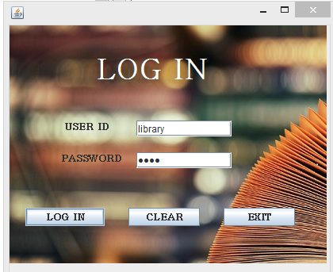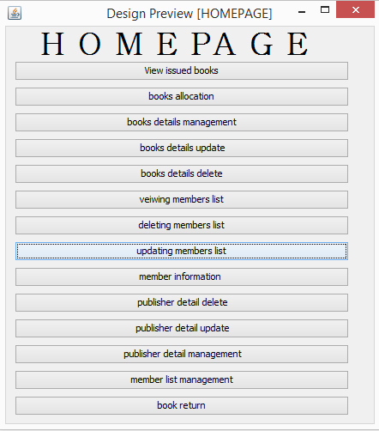

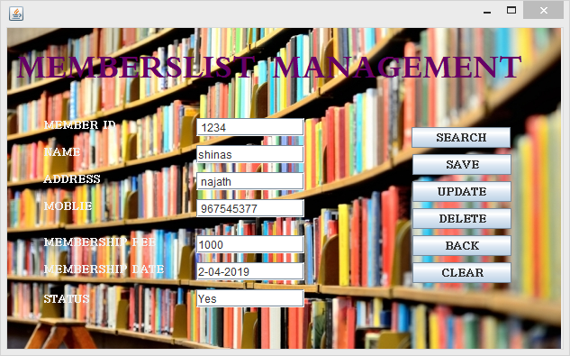

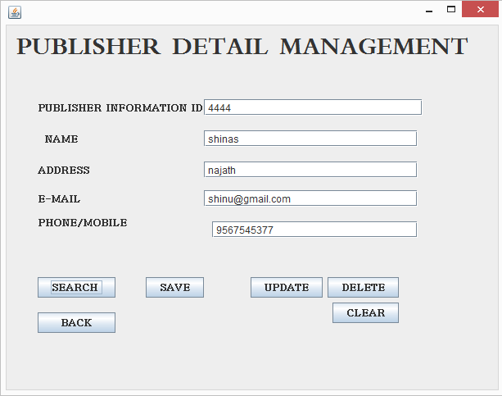

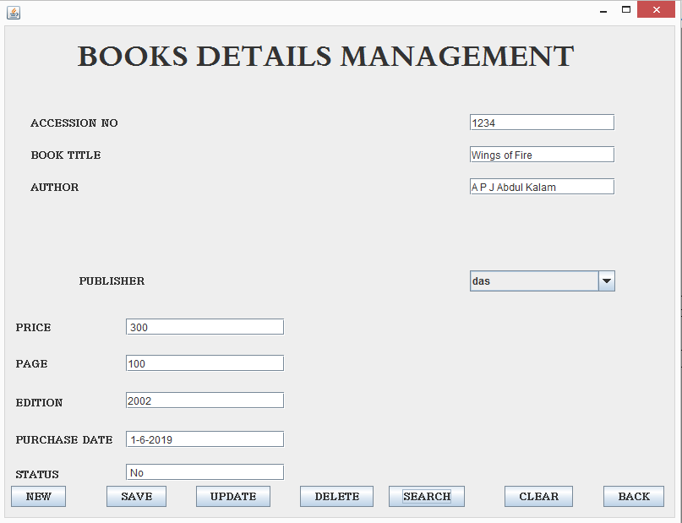 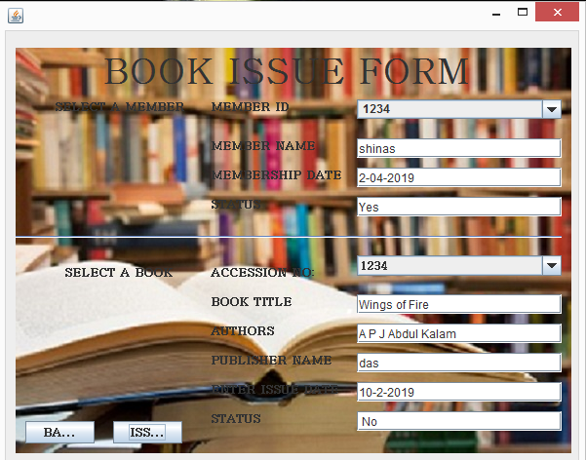 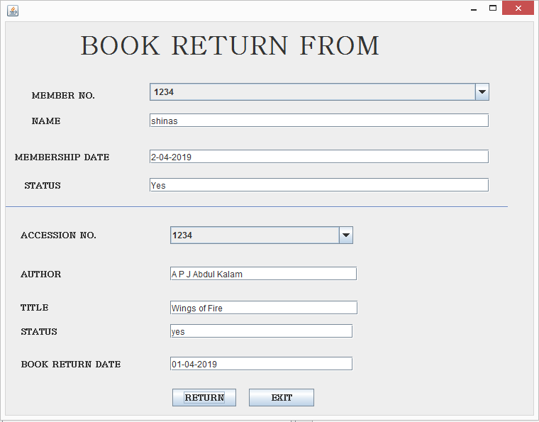 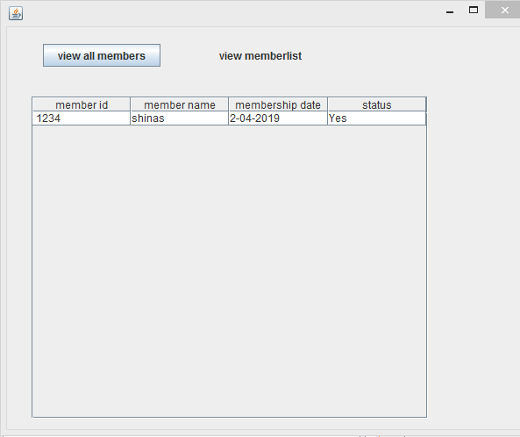 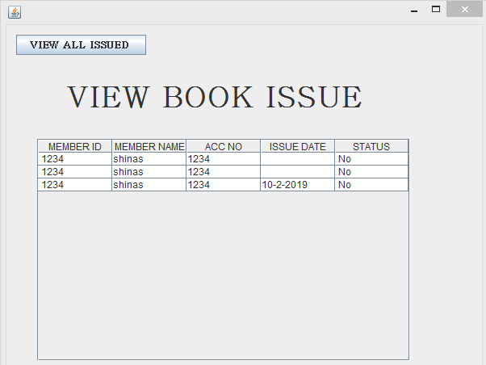

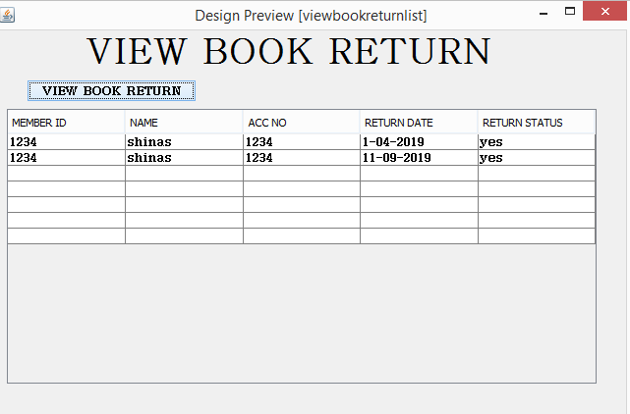

Conclusion

It has been a matter of immense pleasure, honor and challenge to have this opportunity to take up this project and complete it successfully. while developing this project, I have learnt a lot about making large programs and how to make it user friendly by hiding the complicated parts of it from the users.

This project is a small demonstration of how school management system works.

During the development process, I studied carefully and understand the criteria for making software more demanding also realized the importance of maintaining a minimal margin for error.

BIBLIOGRAPHY

1) sumita aurora-informatics practices

2)website-www.netbeans..org

3)www.mysql.org

4)<http://java.sun.com/javase/technologies/desktop>

5)database programming with jd9bc and java by Oreille

6)head first java 2nd edtion